Spring Core and Maven HandsOn
Exercise 1: Configuring a Basic Spring Application

BookRepository.java:
package com.library.repository;

public class BookRepository {
public void saveBook(String bookName) {
System.out.println("Book saved: " + bookName);
}
}

BookService.java:
package com.library.service;

import com.library.repository.BookRepository;

public class BookService {
private BookRepository bookRepository;
public void setBookRepository(BookRepository bookRepository) {
this.bookRepository = bookRepository;
}

public void addBook(String bookName) {
System.out.println("Adding book: " + bookName);
bookRepository.saveBook(bookName);
}
}

MainApp.java:
import com.library.service.BookService;
import org.springframework.context.ApplicationContext;
import org.springframework.context.support.ClassPathXmlApplicationContext;

public class MainApp {
public static void main(String[] args) {
ApplicationContext context = new ClassPathXmlApplicationContext("applicationContext.xml");

BookService bookService = (BookService) context.getBean("bookService");
bookService.addBook("The Great Gatsby");
}
}

OUTPUT:
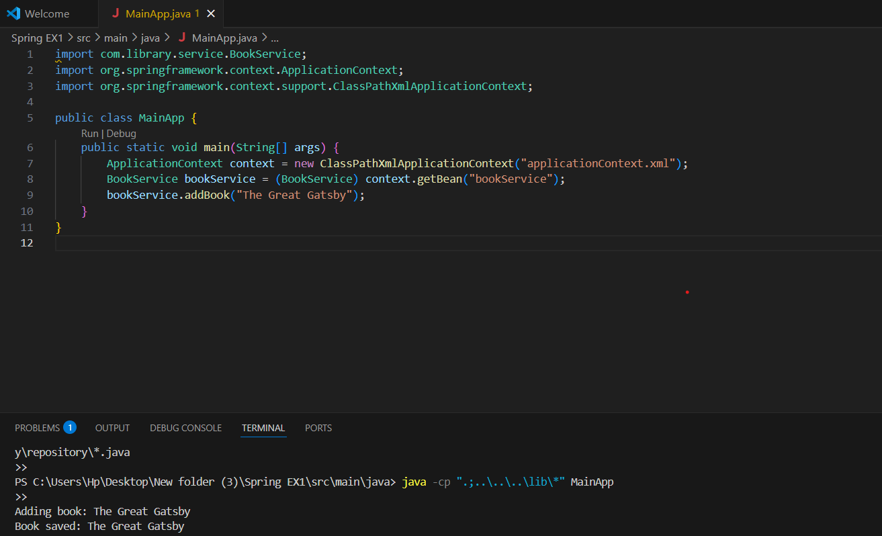

Exercise 2: Implementing Dependency Injection
BookRepository:
public class BookRepository {
public void saveBook(String bookName) {
System.out.println("Book saved: " + bookName);
}
}

BookService:
public class BookService {

private BookRepository bookRepository;
public void setBookRepository(BookRepository bookRepository) {
this.bookRepository = bookRepository;
}

public void addBook(String bookName) {
bookRepository.saveBook(bookName);
}
}

LibraryManagementApplication:
import org.springframework.context.ApplicationContext;
import org.springframework.context.support.ClassPathXmlApplicationContext;

public class LibraryManagementApplication {
public static void main(String[] args) {
ApplicationContext context = new ClassPathXmlApplicationContext("applicationContext.xml");

BookService bookService = (BookService) context.getBean("bookService");
bookService.addBook("Spring in Action");
}
}

OUTPUT:
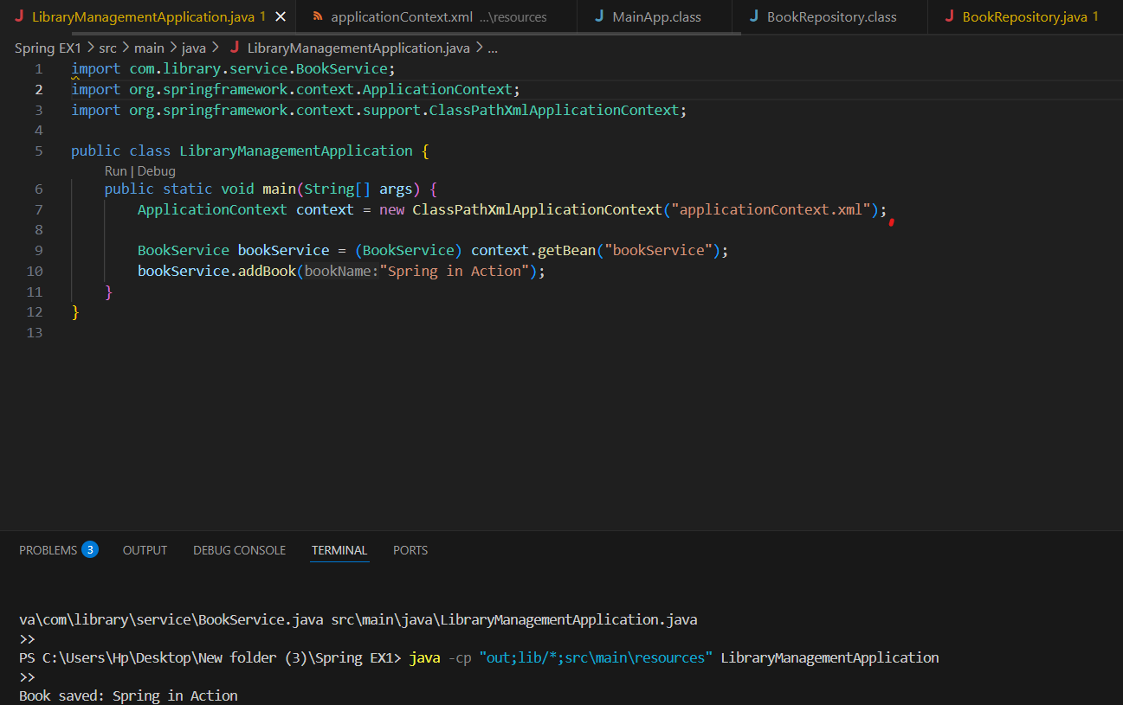

Exercise 4: Creating and Configuring a Maven Project
<project xmlns="http://maven.apache.org/POM/4.0.0"
xmlns:xsi="http://www.w3.org/2001/XMLSchema-instance"
xsi:schemaLocation="http://maven.apache.org/POM/4.0.0
http://maven.apache.org/xsd/maven-4.0.0.xsd">
<modelVersion>4.0.0</modelVersion>

<groupId>com.example</groupId>
<artifactId>LibraryManagement</artifactId>
<version>1.0-SNAPSHOT</version>

<properties>
<maven.compiler.source>1.8</maven.compiler.source>
<maven.compiler.target>1.8</maven.compiler.target>
</properties>

<dependencies>
<!-- Spring Context -->
<dependency>
<groupId>org.springframework</groupId>
<artifactId>spring-context</artifactId>
<version>5.3.36</version>
</dependency>

<!-- Spring AOP -->
<dependency>
<groupId>org.springframework</groupId>
<artifactId>spring-aop</artifactId>
<version>5.3.36</version>
</dependency>

<!-- Spring WebMVC -->
<dependency>
<groupId>org.springframework</groupId>
<artifactId>spring-webmvc</artifactId>
<version>5.3.36</version>
</dependency>

<!-- Optional: Servlet API -->
<dependency>
<groupId>javax.servlet</groupId>
<artifactId>javax.servlet-api</artifactId>
<version>4.0.1</version>
<scope>provided</scope>
</dependency>
</dependencies>
<!-- Maven Plugin Configuration -->
<build>
<plugins>
<plugin>
<artifactId>maven-compiler-plugin</artifactId>
<version>3.8.1</version>
<configuration>
<source>1.8</source>
<target>1.8</target>
</configuration>
</plugin>
</plugins>
</build>
</project>
Output:
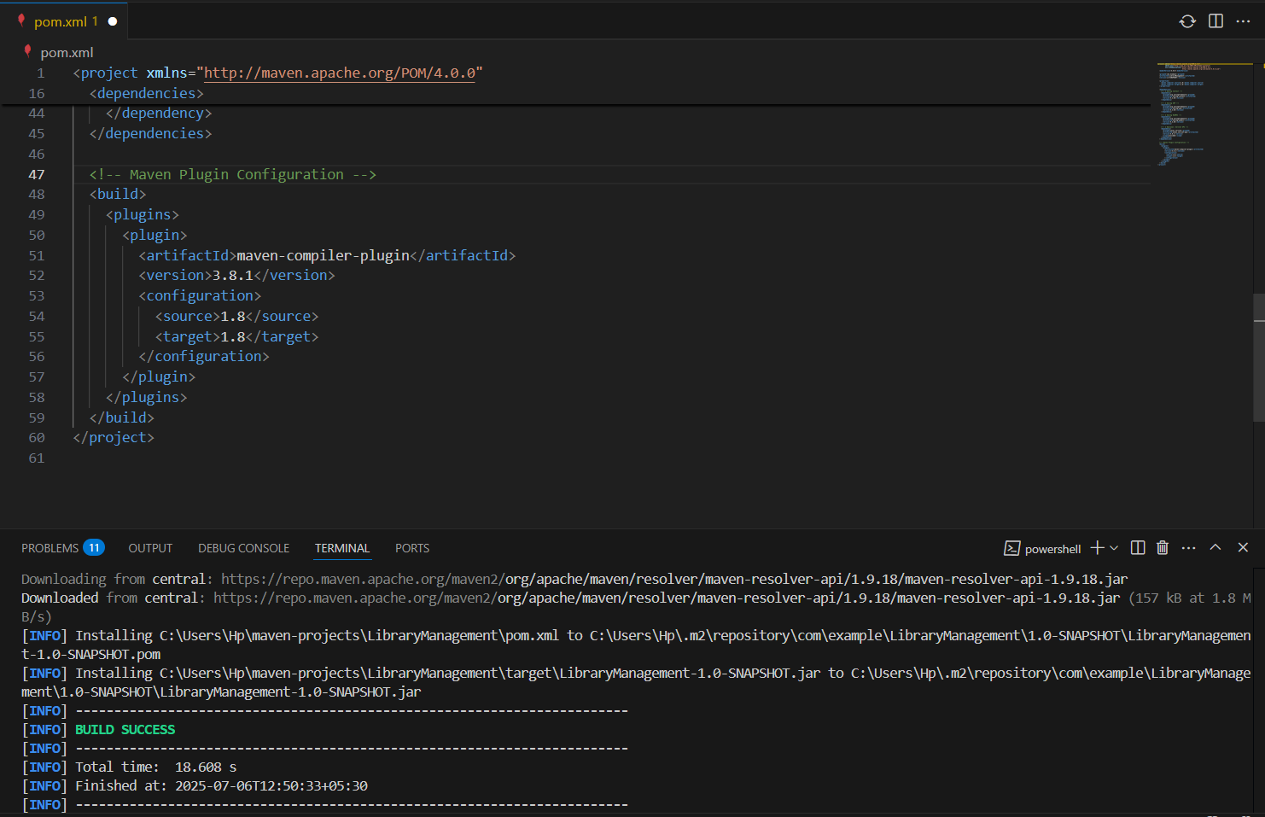
Exercise 5: Configuring the Spring IoC Container

BookRepository.java:
package com.example.repository;

public class BookRepository {
public String getBookTitle() {
return "Effective Java";
}
}

BookService.java:

package com.example.service;

import com.example.repository.BookRepository;

public class BookService {
private BookRepository bookRepository;

// Setter for dependency injection
public void setBookRepository(BookRepository bookRepository) {
this.bookRepository = bookRepository;
}

public void displayBookTitle() {
System.out.println("Book Title: " + bookRepository.getBookTitle());
}
}

LibraryManagementApplication.java:
import com.example.service.BookService;
import org.springframework.context.ApplicationContext;
import org.springframework.context.support.ClassPathXmlApplicationContext;

public class LibraryManagementApplication {
public static void main(String[] args) {
ApplicationContext context = new ClassPathXmlApplicationContext("applicationContext.xml");
BookService bookService = context.getBean("bookService", BookService.class);
bookService.displayBookTitle();
}
}

OUTPUT:

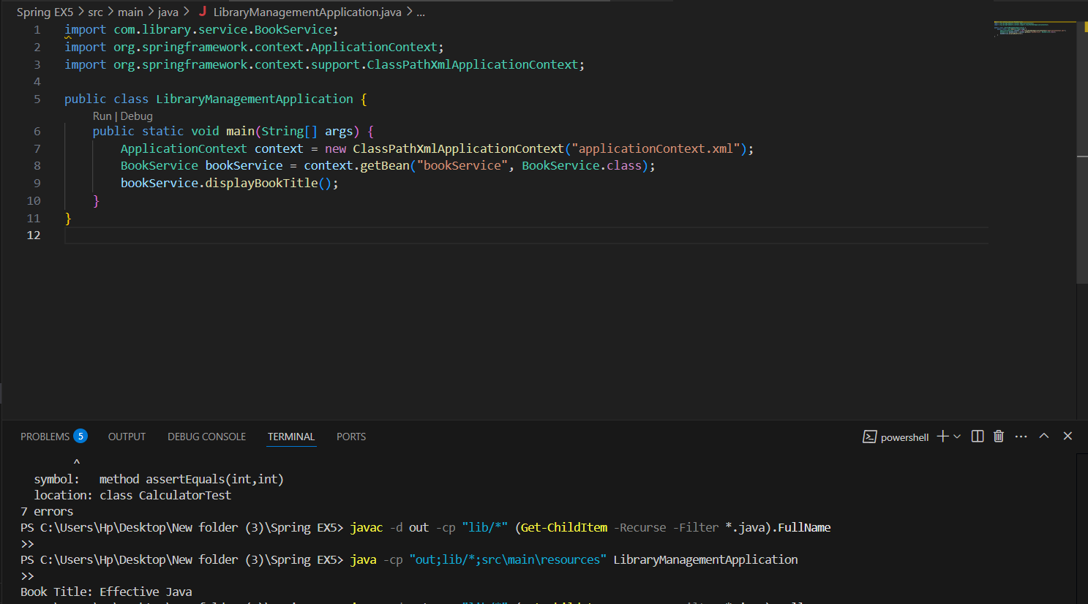

Exercise 7: Implementing Constructor and Setter Injection

BookService.java:

package com.library.service;

import com.library.repository.BookRepository;

public class BookService {
private BookRepository bookRepository;

public BookService(BookRepository bookRepository) {
System.out.println("Constructor Injection: BookRepository injected");
this.bookRepository = bookRepository;
}

public void setBookRepository(BookRepository bookRepository) {
System.out.println("Setter Injection: BookRepository injected");
this.bookRepository = bookRepository;
}

public void displayBookInfo() {
bookRepository.getBookDetails();
}
}

BookRepository.java:

package com.library.repository;

public class BookRepository {
public void getBookDetails() {
System.out.println("Book details fetched from repository.");
}
}

LibraryManagementApplication.java:

import org.springframework.context.ApplicationContext;
import org.springframework.context.support.ClassPathXmlApplicationContext;
import com.library.service.BookService;

public class LibraryManagementApplication {
public static void main(String[] args) {
ApplicationContext context = new ClassPathXmlApplicationContext("applicationContext.xml");
BookService bookService = context.getBean("bookService", BookService.class);
bookService.displayBookInfo();
}
}

OUTPUT:
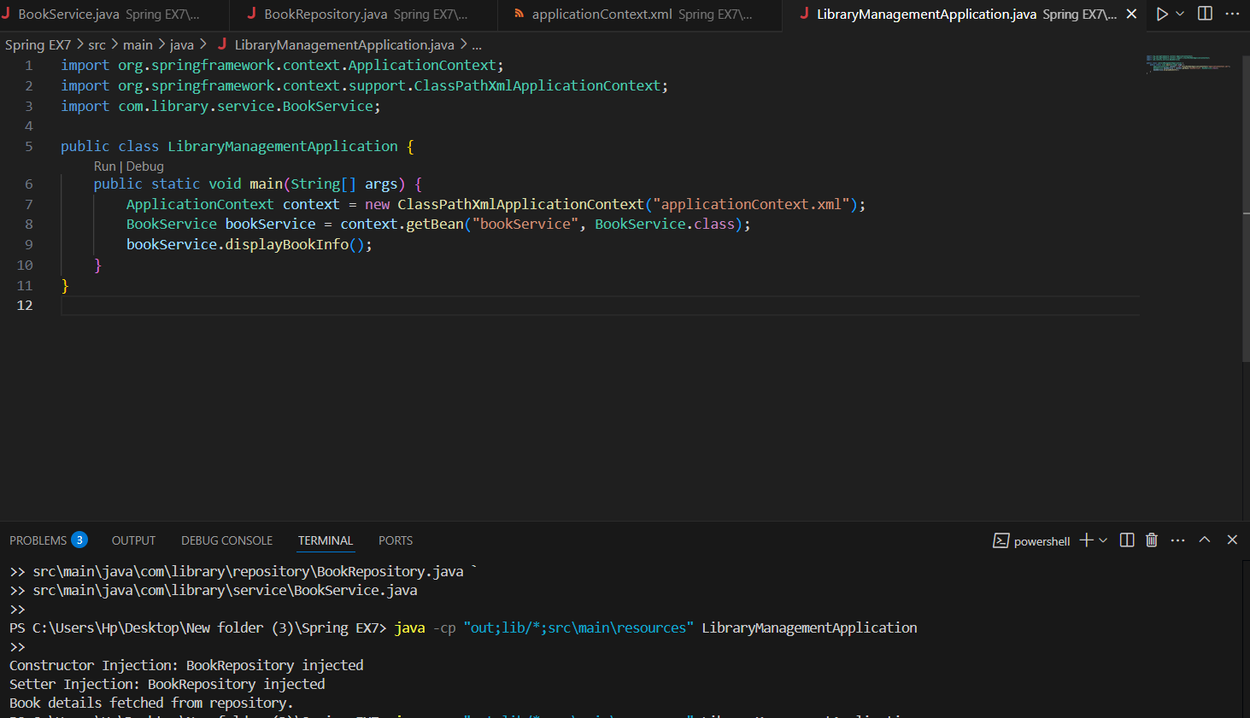

Exercise 9: Creating a Spring Boot Application
Book Entity:
package com.library.entity;
import jakarta.persistence.*;
@Entity
public class Book {
@Id
@GeneratedValue(strategy = GenerationType.IDENTITY)
private Long id;

private String title;
private String author;
private String genre;
public Long getId() { return id; }
public void setId(Long id) { this.id = id; }

public String getTitle() { return title; }
public void setTitle(String title) { this.title = title; }

public String getAuthor() { return author; }
public void setAuthor(String author) { this.author = author; }

public String getGenre() { return genre; }
public void setGenre(String genre) { this.genre = genre; }
}

BookRepository Interface:
package com.library.repository;
import com.library.entity.Book;
import org.springframework.data.jpa.repository.JpaRepository;

public interface BookRepository extends JpaRepository<Book, Long> {
}

BookController
package com.library.controller;

import com.library.entity.Book;
import com.library.repository.BookRepository;
import org.springframework.beans.factory.annotation.Autowired;
import org.springframework.web.bind.annotation.*;
import java.util.List;
@RestController
@RequestMapping("/api/books")
public class BookController {

@Autowired
private BookRepository bookRepository;

@GetMapping
public List<Book> getAllBooks() {
return bookRepository.findAll();
}

@PostMapping
public Book createBook(@RequestBody Book book) {
return bookRepository.save(book);
}

@GetMapping("/{id}")
public Book getBookById(@PathVariable Long id) {
return bookRepository.findById(id).orElse(null);
}

@PutMapping("/{id}")
public Book updateBook(@PathVariable Long id, @RequestBody Book updatedBook) {
return bookRepository.findById(id).map(book -> {
book.setTitle(updatedBook.getTitle());
book.setAuthor(updatedBook.getAuthor());
book.setGenre(updatedBook.getGenre());
return bookRepository.save(book);
}).orElse(null);
}
@DeleteMapping("/{id}")
public void deleteBook(@PathVariable Long id) {
bookRepository.deleteById(id);
}
}

LibraryManagementApplication.java:
package com.library;

import org.springframework.boot.SpringApplication;
import org.springframework.boot.autoconfigure.SpringBootApplication;

@SpringBootApplication
public class LibraryManagementApplication {
public static void main(String[] args) {
SpringApplication.run(LibraryManagementApplication.class, args);
}
}

OUTPUT:
